BDD vs TDD
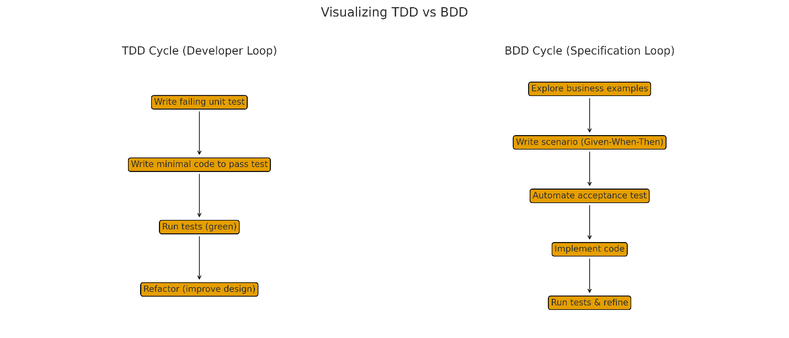
Quick definitions
TDD (Test-Driven Development): developers write a small failing unit test first, then implement just enough code to make it pass, then refactor. Tight developer feedback loop focused on correctness and design.
BDD (Behavior-Driven Development): teams (devs, QA, product/stakeholders) express behaviors as human-readable, executable scenarios (Given-When-Then). These scenarios drive acceptance-level automation and help align code with business requirements.
Visuals
I showed two visuals:
- A side-by-side flow diagram of the TDD cycle (write failing unit test → write code → run tests → refactor) and the BDD cycle (discover examples → write scenarios → automate acceptance tests → implement → run and refine).
- A comparison table (displayed as a table) that highlights primary focus, test style, who writes tests, level of tests, typical artifacts, feedback speed, when to use, and main benefit.
(If you want these exported as an image or a slide deck, tell me and I’ll produce a downloadable file.)

Unique approaches (concise)
TDD
- Micro-level, developer-first.
- Tests drive code design and API shape.
- Uses frequent, fast cycles (red → green → refactor).
- Tests are typically unit tests using frameworks like JUnit, pytest, NUnit.
BDD
- Behavior-first and collaboration-heavy.
- Uses business-readable scenarios (Given-When-Then) that serve as living requirements and acceptance tests.
- Bridges domain language between nontechnical stakeholders and developers.
- Framework examples: Cucumber, SpecFlow, Behave.
Benefits
TDD
- Encourages modular, testable design and lower defect rates in units.
- Fast developer feedback — easier, safer refactoring.
- Clear unit coverage; supports CI with quick failures.
BDD
- Ensures software matches business expectations; reduces misunderstandings.
- Produces living documentation (scenarios = documentation).
- Useful when acceptance criteria must be clear and validated by stakeholders.
Suitability (where each shines)
TDD is best when:
- You need strong internal code quality.
- Problem domain is algorithmic or requires careful unit correctness.
- Small teams or components where developer-driven tests are enough to define behavior.
BDD is best when:
- Product requirements need to be validated by non-developers (POs, QA, clients).
- Multiple stakeholders must agree on behavior (complex workflows, compliance).
- You want executable specifications that double as documentation and acceptance tests.
Practical hybrid approach
Most mature teams use both:
- Use TDD inside components to design clean APIs and catch unit bugs.
- Use BDD for high-level features and acceptance criteria to align with the business and drive end-to-end tests.
This gives the fast safety net of unit tests plus the business confidence from behavior tests.
Quick recommendations
- New codebase focused on API correctness or libraries → prioritize TDD.
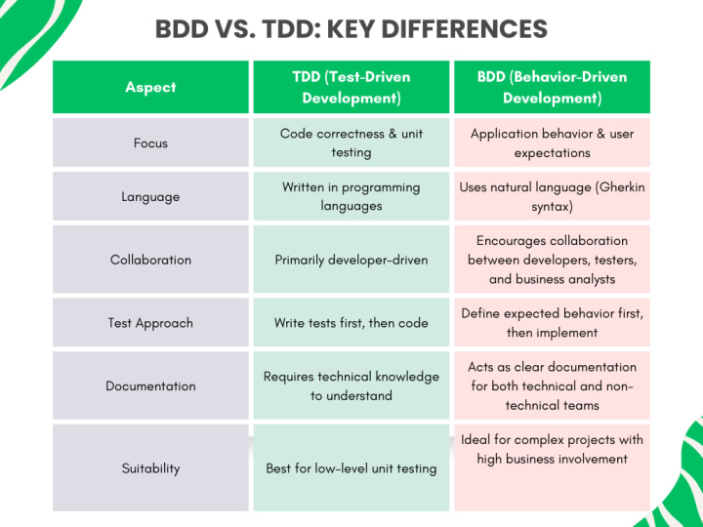
- Feature-heavy product where stakeholders must validate behavior → prioritize BDD for acceptance, with TDD for internals.

